Quentin Stuckey
ENG 623
Dr. Nima Naghib
November 23rd 2019
Bold Colour with Detached Narration: Trauma in Riad Sattouf’s The Arab of the Future
As a complex psychological condition, “trauma” can be simply defined as “a memory that has not been processed, but instead recurs to consciousness to be evaluated and processed at a later time” (Winslow 16) with the “memory” usually being one of an adverse experience (s) and manifesting in a whole host of signs/symptoms. These typically include flashbacks, intrusive dreams, anxiety, depression and avoidance of particular stimuli (Mayo Clinic). Individuals suffering from the impacts of a traumatic event or upbringing often turn to forms of artistic expression, such as literature, to make sense of their memories. However, according to Anne Whitehead in her text Trauma Fiction: “if trauma comprises an event or experience which overwhelms the individual and resists language or representation, then how can it be narrativized in fiction?” (qtd. in Leary). If traumatic experiences can hinder “language or representation” in the fictional form, this form being comprised of text only, many theorize that graphic novels are able to articulate an individual’s trauma through the combination of text and image. In The System of Comics, writer Thierry Groensteen states that comics function as “an image-based story…each element, whether it is visual, linguistic…participates fully in the narration” (11). Groensteen outlines crucial elements which constitute the comic narrative: the visual (such as illustrations) and the linguistic (such as speech bubbles). Furthermore, writer Sebastian Eric Christoph Winslow, in his dissertation on trauma in coming of age comics, states the word and the image comprise “two layers of meaning” within the genre (8). Since the comic or graphic novel is composed of two layers of narrative and “meaning,” individualized trauma, according to Jennie K. Leary in her work on trauma comics set in the Middle East, can be “delivered visually through color, panel size and repetitive imagery…[providing] the resources for illustrating the impact of traumatic experience” (4). Winslow attests to this argument when he states “Comics are often perceived as ‘just funny pictures,’ and trauma is often classified as ‘just bad memories’” (9). When an artist chooses to recount their “bad memories” through the visual/textual mode of “funny pictures,” the result is rather unique (Winslow). Trauma narratives are conveyed through this interplay between the meaning of the image and the meaning of the text. This interplay can often present a word/image irony “whereby the text and the visuals in a panel or sequence of panels contain clearly contradictory information about the same event” (Molotiu). The comic image can convey one meaning while the text conveys a contrary meaning: creating contradiction and tension. Within this theoretical framework, Riad Sattouf’s 2015 graphic novel The Arab of the Future: A Childhood in the Middle East, 1978-1984 is worthy of critical examination due to its graphic form and depicted content. The graphic autobiography focuses primarily on the young Riad’s experiences growing up in the post revolutionary political climate of Libya and Syria. Sattouf also portrays his relationships to his Syrian father Abdul-Razak and his French mother Clémentine. Violent and emotionally disturbing events/situations are depicted, as Sattouf’s family’s experiences were clearly influenced by extreme political, social and environmental factors. Through the utilization and tension between selective bold colouring and non diegetic narration, the experience and symptoms of trauma are depicted from an ambivalent perspective in The Arab of The Future. Sattouf’s depiction of trauma is signified by the visual use of bold colouring along with the use of reflective yet detached non diegetic narration. These two expressive modes of the graphic novel stand in contradiction to one another, thus creating an attitude of ambivalence towards the experience of trauma. This degree of ambivalence furthermore indicates the difficulty of recounting childhood experiences within the context of diasporic roots.
As the expression of trauma lends itself to the visual/textual mode of comics, visual elements like colour or panel size are able to visually articulate “the impact of traumatic experience” (Leary 9). In The Arab of the Future, cartoonist Riad Sattouf’s most utilized visual mode is colour. Colour is significantly utilized to indicate a change in the narrative’s location, shading in the general composition of the pages (Naghib). A mustard yellow indicates the setting of Libya, a navy blue indicates the setting of France and a pinkish red indicates the setting of Syria (Naghib). Other colour compositional schemes appear in the comic as well, including green (see Fig. 5), but yellow, blue and red are primarily used. The colour scheme typically appears in a muted tone cast with varying degrees of shadow and light, however there are significant instances where bold colouring is used. As trauma or memories of adverse experiences can manifest in the form of intrusive dreams, flashbacks and feelings of anxiety/depression (Mayo Clinic), the use of bold colouring visually signifies these traumatic experiences/symptoms in the graphic novel. In a panel depicting a dream sequence (see Fig. 1), Riad ventures down a long yellow hallway with his tiny stature casting a long, dark shadow (Sattouf 11). In the third panel, a black bull with piercing green eyes appears at one end of this hallway (11). Riad attempts to escape at the opposite end of the hallway, only to find an additional green eyed, black bull approaching towards him (11). The two bulls then charge at him in the fifth panel, when suddenly a hand reaches down from above and rescues him in the next panel (see Fig. 1.2). In the first column, it is revealed to be his father, illustrated in full, bold yellow (12). He places Riad back in his crib with his bold yellow hand in the second panel (12). He then goes back to watching television in the third panel, no longer being completely yellow but returning to the already established colour composition with a shade of white hitting the corner of his eye (12). Another example of bold colouring occurs when Abdul-Razak’s exclamatory speech bubble is depicted in dark red, going after three Syrian boys with his shoe to defend his son (see Fig. 3). In the next column, the gutters completely disappear as Abdul-Razak continues to viciously beat the boys, his speech bubble still emboldened in red (91). In another dream sequence, Riad is in bed next to his mother (see Fig. 4). She is coloured in the pinkish red associated with the Syrian composition, when suddenly in the fourth panel: she lurches and roars at Riad fully coloured in dark red and dawning black eyes (136). In the next column, a dark black figure appears next to Riad, and in the final panel, it is revealed to be his father feeding him medicine (136). Additionally, in another panel Riad is presented as sleeping soundly in bed, coloured fully in the pinkish red associated with Syria (see Fig. 2). In the second column, he is suddenly awoken by a loud speaker announcing morning prayers with the speech bubbles coloured in dark green (77). In the last panel, he hears the shrill sound of dogs howling as signified by the speech bubble’s oval shape and dark red colourization (77). When considering the content of the images, they all depict difficult and frightening situations. Riad dreams that he is about to be gored by two black bulls until he is saved by his father’s yellow hand. Abdul-Razak is seen aggressively beating young Syrian boys, his anger exemplified by the dark red speech bubbles. Riad imagines his mother aggressively turns on him equipped with black eyes and coloured in dark red. His sleep is disrupted by the sounds of loud praying and howling dogs, once again punctuated by the bold colours green and red. This utilization of bold colouring stands in opposition to the general arthrology of the comic narrative, since colour is usually contrasted with light and shadow. These events consisting of Riad’s frightening dreams, his father’s violence and his abrupt awakening at night indicate traumatic memory and are visually signified by this change in colour tone. This change in colour seizes the reader’s attention and highlights the intensity of the content depicted. Therefore, Sattouf utilizes this bold colouring to visually indicate Riad’s intrusive dreams, his witness of violent events and his feelings of anxiety, thus signifying traumatic experience through a change in colour tone, standing in contrast to the comic’s already established arthrology.
In addition to the visual elements in a comic working to depict trauma, the textual comprises an additional layer of meaning (Winslow). Words in comic books are primarily featured in speech bubbles: what the characters say in the diegesis, and text boxes: what the narrator says in the non diegesis (Molotiu). The text box typically “allows for separation between narrator and protagonist, as the visual image can recreate the protagonist in the past while the text delivers the [non-diegetic] voice of the narrator” (Versaci 38 qtd. in Leary 5). Furthermore, the nature of autobiographical comics employs two modes of narratorial authority: the narrated “I” and the narrating “I” (O’Malley). The narrated “I” serves as the visually depicted protagonist whereas the narrating “I” serves as the older protagonist reflecting upon their experiences (O’Malley). Since the text box serves to “separate” the “narrator” and the “protagonist” (Versaci), distinguishing between the narrated “I” in the diegesis and the narrating “I” in the non diegesis (O’Malley), Sattouf utilizes detached, non diegetic narration to further depict traumatic experience/symptoms in The Arab of the Future. During the first dream sequence (see Fig. 1), the narration consists of Riad, as the narrating “I”, stating “At that age, I had great difficulty working out the difference between dream and reality, especially at night” (Sattouf 11). When he begins to describe the two black bulls charging at him, he states “The two beasts were just about to skewer me on their horns…” (11). Then when describing his father’s abrupt rescue, he states “He put me back to bed…” and in the next panel he states “…and carried on watching TV” (12). Despite recounting a rather frightening dream, the non diegetic narration is surprisingly detached. This is exemplified by the choice in punctuation. Rather than utilizing exclamation points to describe the dramatic image of two bulls charging, ellipses are used. The use of ellipses stands in opposition to what is being depicted visually, it underscores the traumatic image thus the narration is characterized as detached. After describing his abrupt awakening at the sound of morning prayer (see Fig. 2.2), he states “My father wasn’t there. I was shivering. My mother was feeding Yahya. It was so cold, my breath steamed” (78). Here once again, Sattouf is employing a detached tone when describing the cold environment he awoke in and the surprising absence of his father. He states these difficult circumstances matter-of-factly, as demonstrated by the short, abrupt sentences not exemplified but deemphasized by the use of periods. He describes how he observed his mother “watching my brother with a strange expression. There’d been another power outage” (136). It is then that Riad experiences the terrifying image of his mother lurching at him (see Fig. 4), yet once again the detached narration dryly states the fact that there had “been another power outage.” The most effective example of this detachment occurs after witnessing his father attack the Syrian bullies (see Fig. 3). Riad describes how he “was thrilled by the sight of their faces twisted in pain and misery…but after a while, I began to feel something strange” (91). Then, visually we see a crudely drawn arrow pointing to his small frame stating “I was afraid that I’d be next” (91). Rather than articulating this understandable trepidation from seeing his father’s violent behavior, the description of fear is visually drawn into the panel rather than included in the non diegetic narration. This once again detaches the tone of the narration, quite literally placing the emotion of fear away from the text box and into the visual field of the last panel. Sattouf’s choices in punctuation, (especially ellipses and repeated use of periods) along with his refusal to emotionally comment on the nightmarish images, the violent events and difficult circumstances (except in an off-hand comment in the last panel of Fig. 3) therefore creates a detached narratorial style. This detached tone of narration through the text boxes serves to textually depict traumatic experiences and symptoms. Furthermore, when the bold coloured images are combined with the detached narration, there is clear contradiction and tension.
Since narratives of trauma are conveyed through the interplay between the image and the text, this interplay can occasionally present a word/image irony. The text portrays one degree of information while the image portrays contrary information (Molotiu). Riad Sattouf’s use of bold colourization combined with detached narration serves to contradict one another, indicating an ambivalent perspective towards these traumatic experiences/symptoms. Despite the visual depiction of the two charging black bulls (see Fig. 1), the narration remains detached as demonstrated by the lack of exclamation in favour of ellipses. After the final announcement of “GOD IS GREEEAAAT!” (Sattouf 78) embolden in green (see Fig. 2.2), Riad wakes up shivering, with his father gone and his mother paying no attention to his physical state. The narration once again is characterized with abrupt, matter-of-fact wording, merely stating “It was so cold, my breath steamed” (78) with no further comment. Riad’s father’s aggression is visually signified by the bold colour red (see Fig. 3) yet the fear which Riad describes is not included in the narration, but rather as a visual aside in the last panel. His mother is depicted as fully coloured red, black eyed with jagged teeth (see Fig. 4) after Riad dryly asserts that “there’d been another power outage.” Full, bold colouring emphasizes the nightmarish images of charging bulls, his mother’s monstrosity, his father’s violence and the anxious disruption of sleep due to loud howling and praying. Yet, Sattouf’s use of text boxes to narrate these experiences from the narrating “I” contradicts these images. The short sentences, lack of emotional comment on the events and lack of exemplary punctuation characterizes the narration as detached both in tone and from the visuals depicted. The strong colour tone of the illustrations is drawing attention to the adversity of these memories, feelings and dreams. However, the detached narration deemphasizes the visuals since the words do not present the expected dramatic linguistic expression, which ought to characterize trauma. Thus, this word/image dichotomy creates ambivalence towards the subject matter. The images are attempting to emphasize trauma while the words deemphasize the experiences, thus it is unclear how the cartoonist feels towards the trauma or how the reader ought to interpret the experiences. This ultimately creates ambivalence. The colour of the images cast the events as unsettling yet the words remain detached from the events. Therefore, the two expressive modes of the graphic novel stand in contradiction to one another, thus creating this attitude of ambivalence towards the experience of trauma.
The word image irony between the colourful depiction of traumatic events, nightmares, feelings and the detached, inexpressive narratorial tone creates a sense of ambivalence towards Riad Sattouf’s childhood growing up in the Middle East. Visually, trauma is boldly coloured, in contrast to the rest of the comic’s negotiation of colour, exemplifying the adversity of these experiences. Textually, trauma is underscored by abrupt sentence structure, little exemplary punctuation and a lack of emotional resonance embedded in the narration, deemphasizing the adversity of these experiences. Because of this contradiction, the reader is left uncertain as to how Sattouf, writing a graphic autobiography, feels towards the subject matter. This casts a perspective of ambivalence towards the experience of trauma. This ambivalent perspective furthermore indicates the difficulty of retelling childhood events in the context of diasporic roots. Sattouf, both as the character in the comic and by proxy in his personal life, lived in three culturally different locations from 1978-1984: Libya, France and Syria, spending most of his childhood in the Middle East. The differing political and cultural climates in these countries were at odds during this time period, especially considering the movement of pan-arabism (Naghib). This movement sought to unite the Middle East in response to the region’s division into nation states by Imperialist powers (Naghib). Sattouf’s childhood was clearly traumatic but it was also diasporic: his father’s own migration from Syria to study in France laid down these diasporic roots, with the child Riad relegated to constant migration in the comic. How does an individual reconstruct not only a childhood plagued by adversity, but also one originating from diaspora? The Arab of The Future, and its ambivalent portrayal of childhood trauma thus indicates how difficult it is to recount childhood in the context of diasporic roots. Sattouf’s upbringing was far from ideal, yet his family’s roots complicate this upbringing because of the constant cultural transience. It’s as if the adult Sattouf’s only resources to understand his past are colour, drawings and words. The contradictory visual/textual codes echo more than just trauma, they echo the scattered nature of diaspora. These modes do not allow us as the reader to make cohesive sense of his experiences, perhaps because the writer/subject cannot either. Just as trauma can resist representation (Whitehead qtd. in Leary), so too can the constant migration between differing political/social climates at an impressionable age, as demonstrated by Riad Sattouf’s comic autobiography.

Appendix
1.
.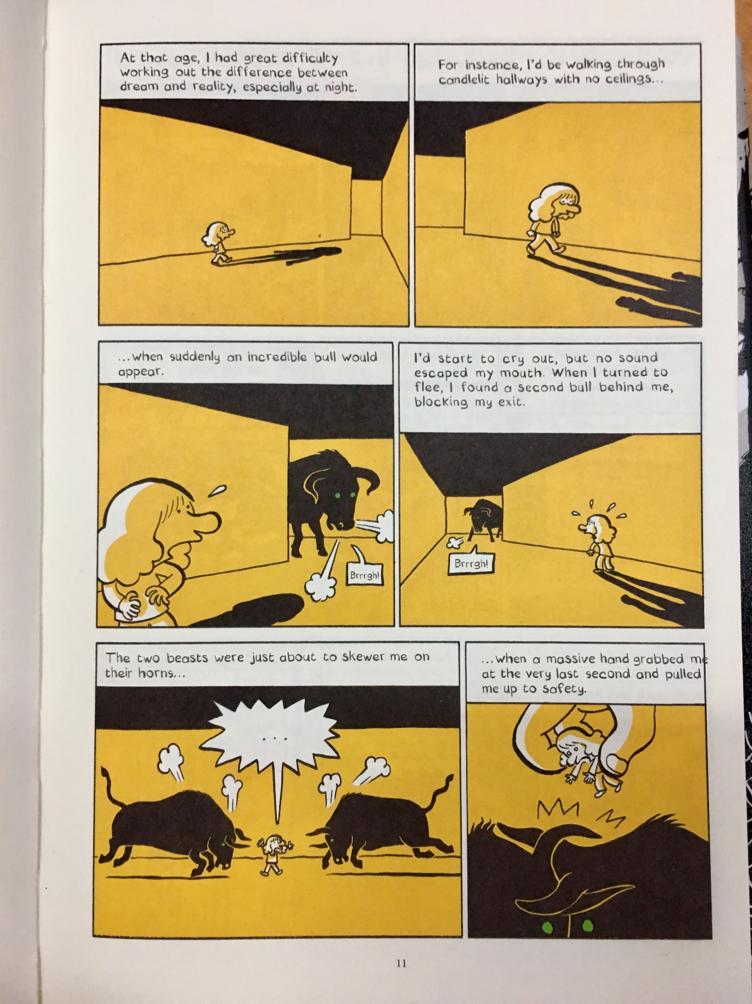
1.2
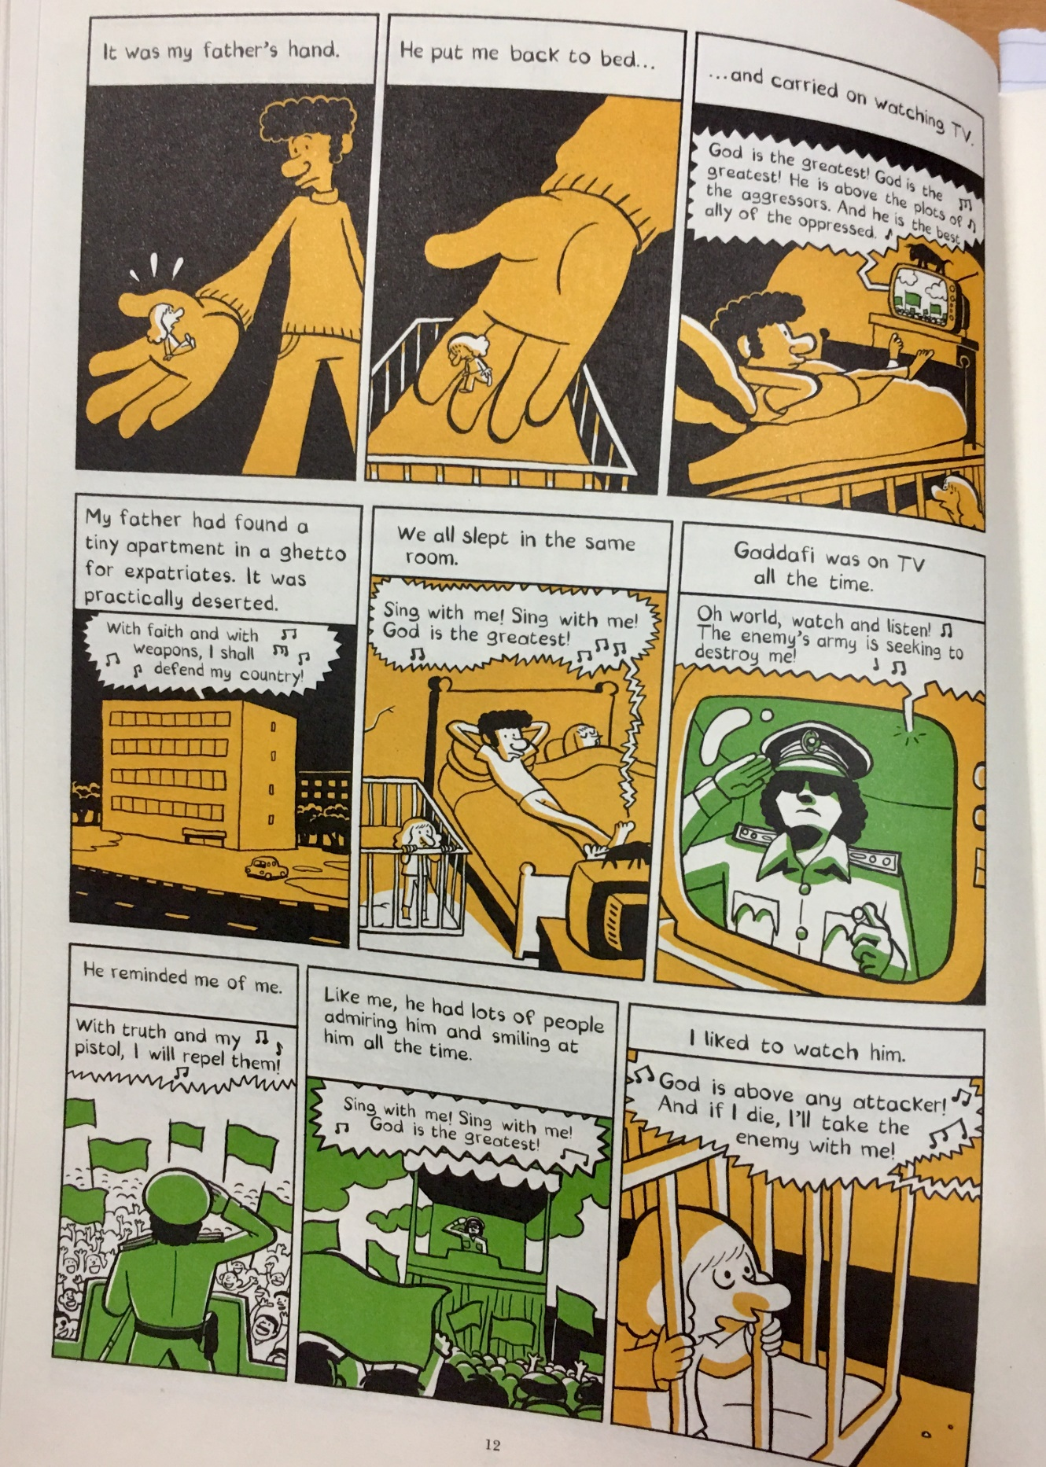
2.
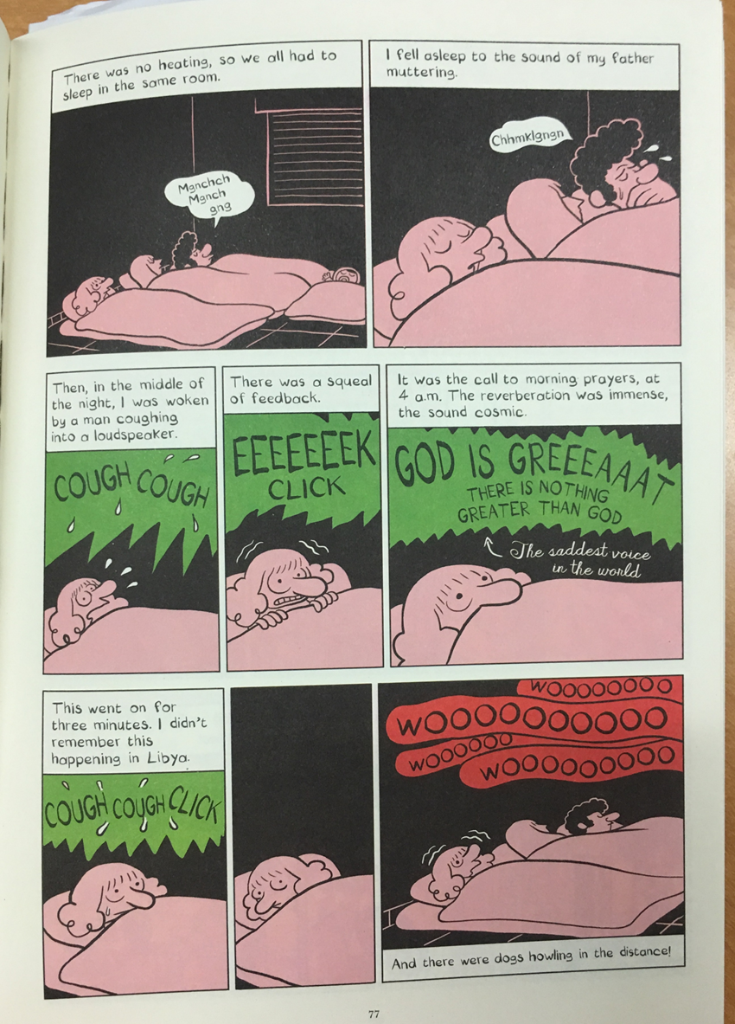
2.2
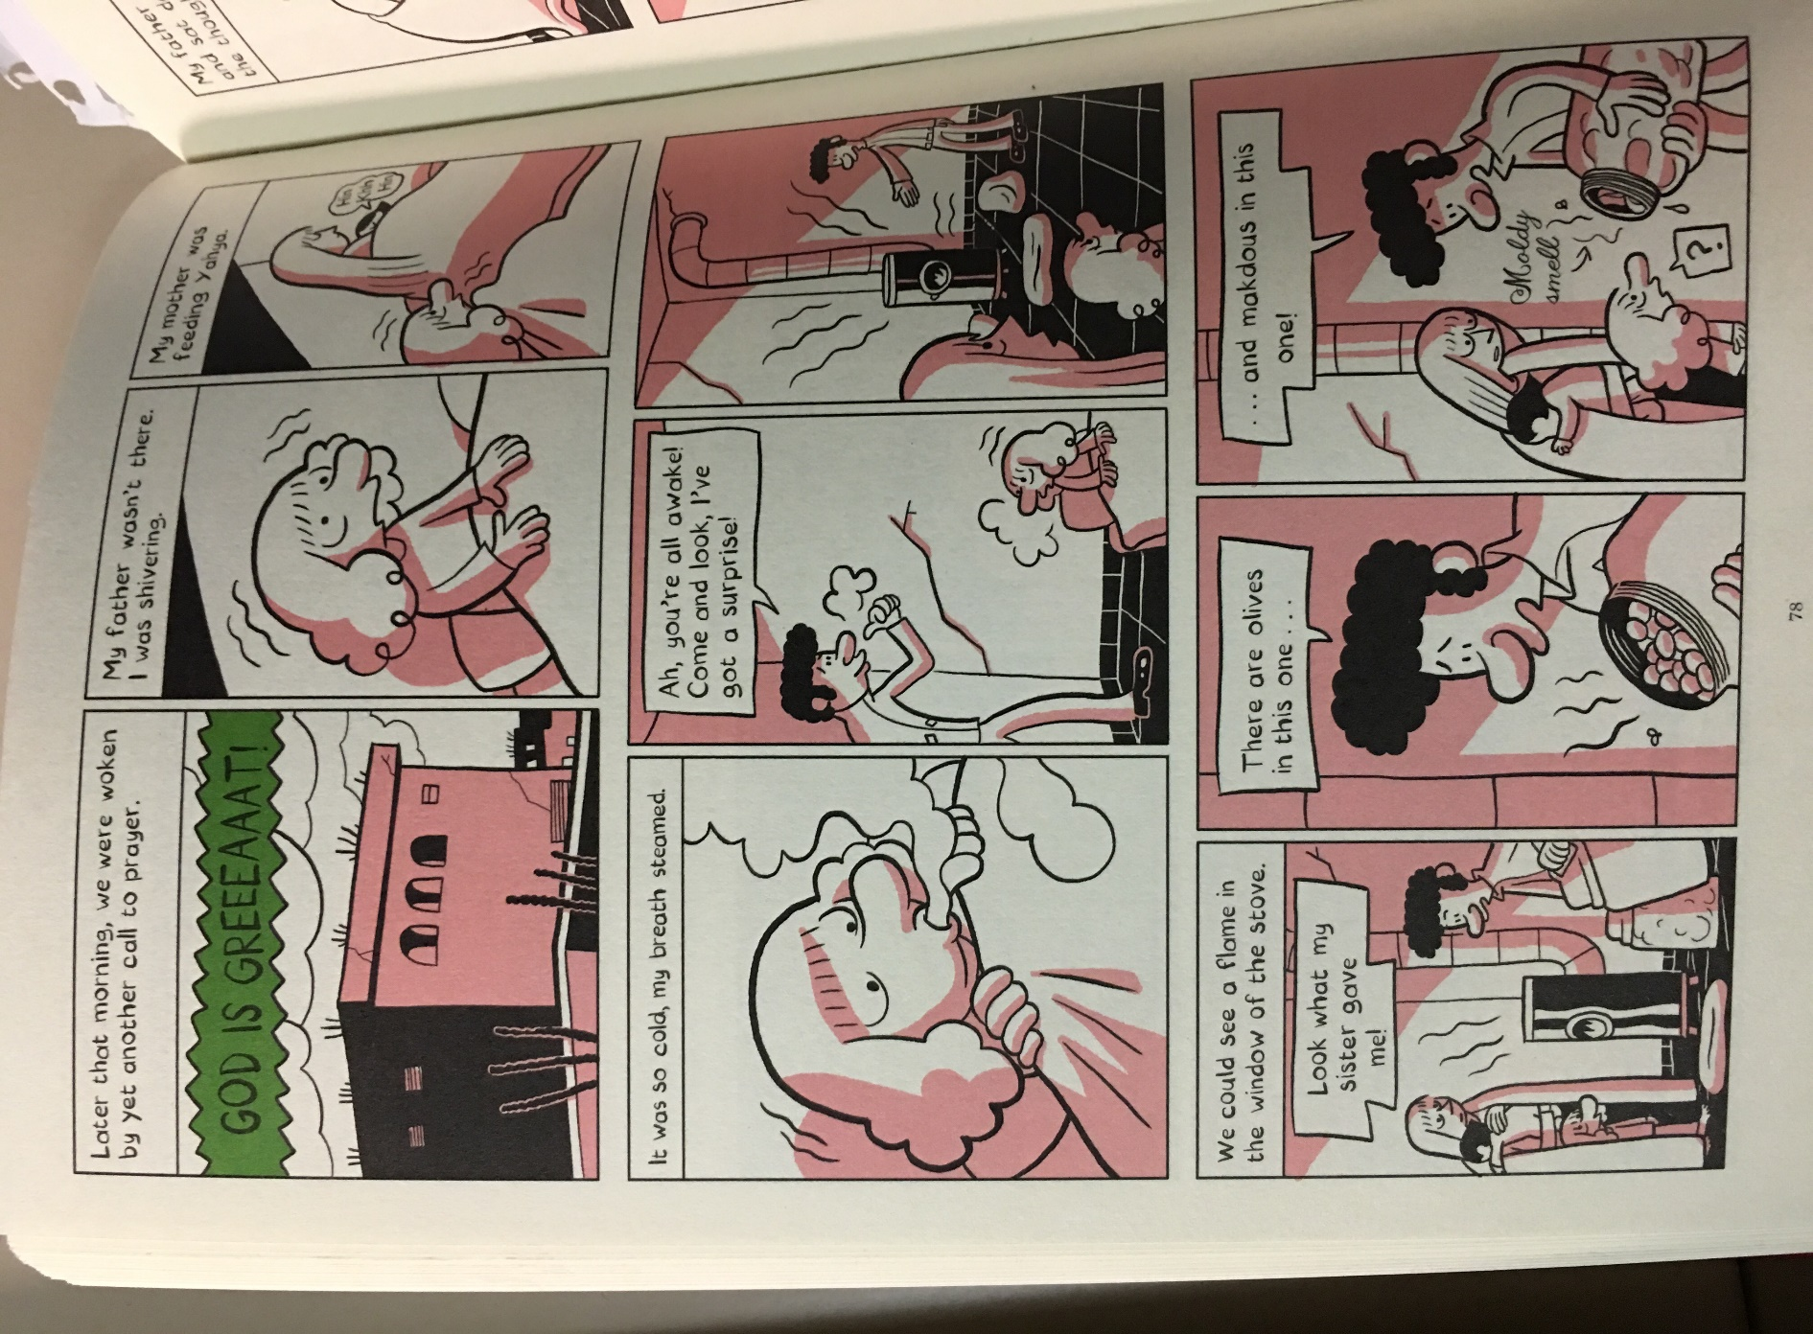
3.
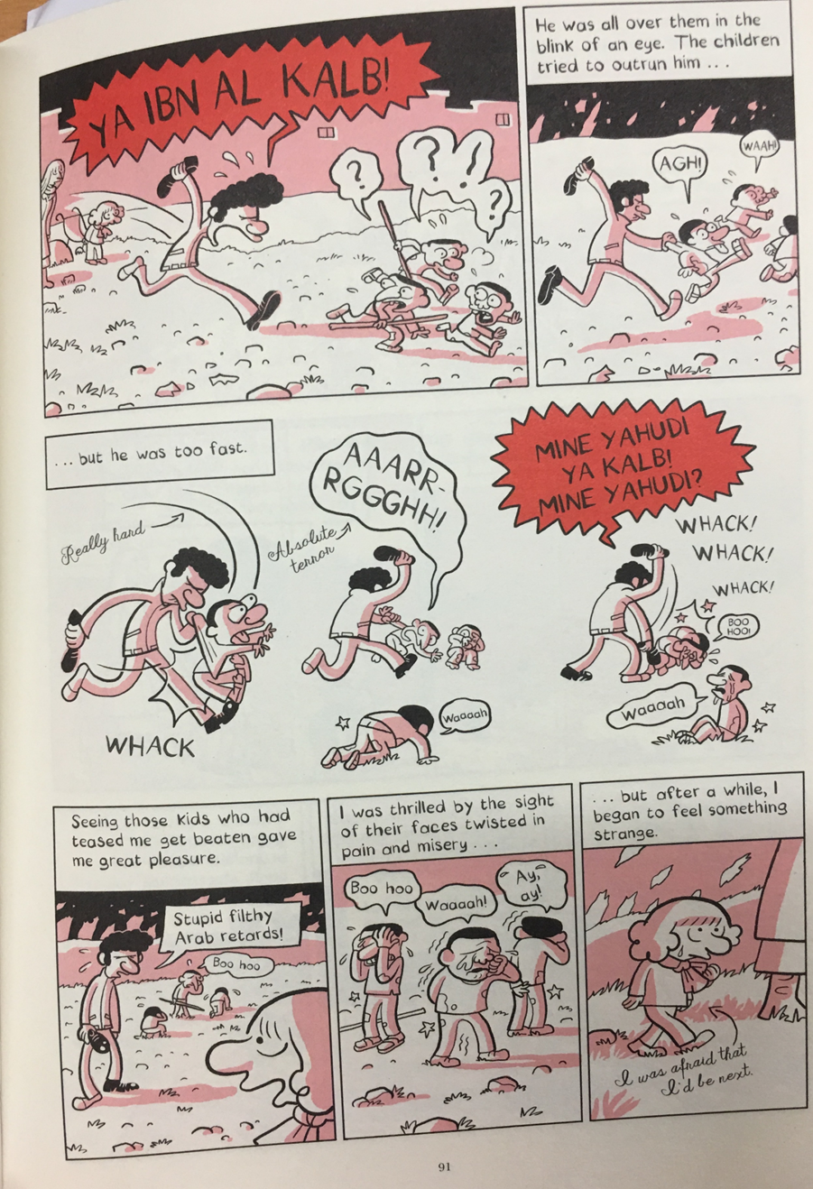
4.
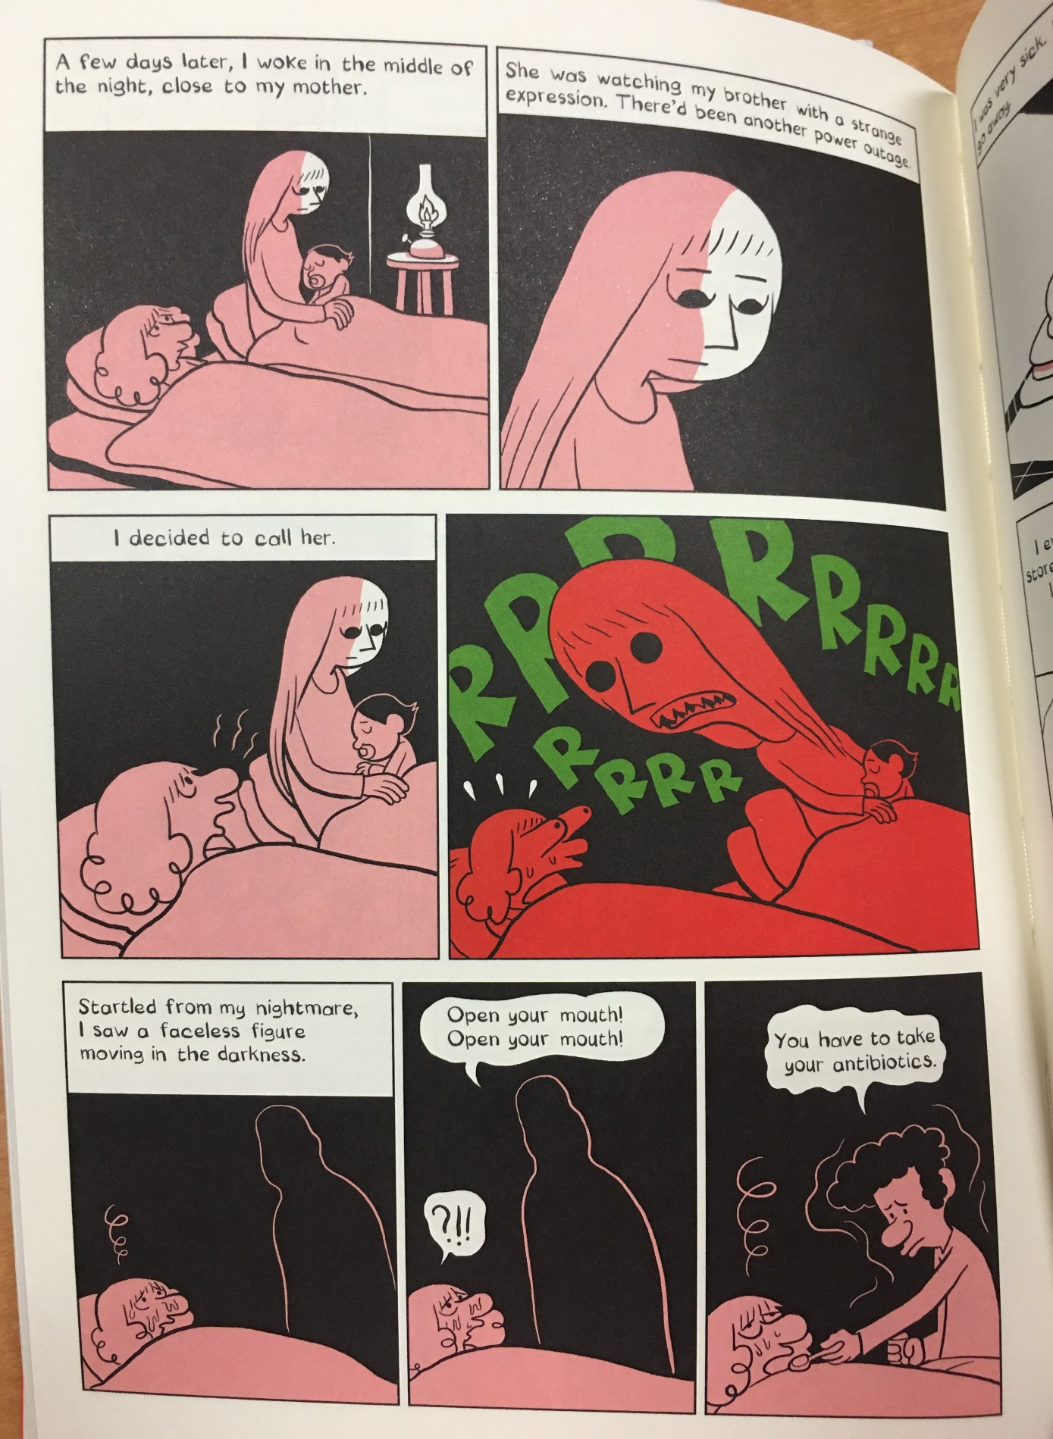
5.
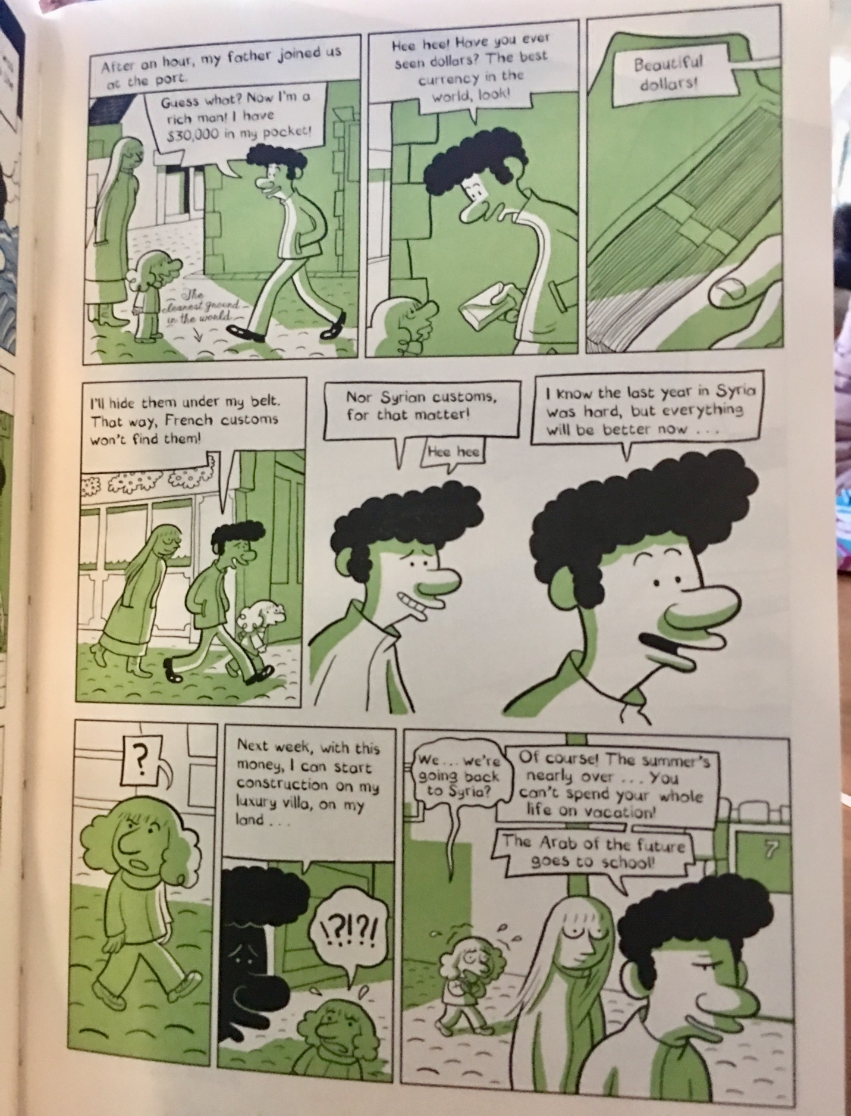
Works Cited
1. Groensteen, Thierry. “Introduction.” The System of Comics, University Press of Mississippi, 2007, https://courses.ryerson.ca/d2l/le/content/297042/viewContent/2467473/View
2. Leary, Jennie K. “Representations of War and Trauma in Graphic Novels from the Middle East.” West Chester University of Pennsylvania, ProQuest Dissertation Publishing, 2011. ProQuest, https://search-proquest-com.ezproxy.lib.ryerson.ca/docview/1825398770/fulltextPDF/F2209F149BCF4A4APQ/1?accountid=13631.
3. Molotiu, Andrei. “List of Terms Fir Comics Studies.” Comics Forum, 2013, https://comicsforum.org/2013/07/26/list-of-terms-for-comics-studies-by-andrei-molotiu/.
4. Naghib, Nima. “Arab of the Future.” ENG 623, November 4th 2019, Ryerson University, Toronto, Ontario. Lecture.
5. O’Malley, Andrew. “Underground Comics.” ENG 910, October 2nd 2019, Ryerson University, Toronto, Ontario. Lecture.
6. Pizzino, Christopher. “Comics and Trauma: A Postmortem and a New Inquiry.” Interdisciplinary Comics Studies, vol. 9, no. 1, 2017. Ryerson University Library, http://imagetext.english.ufl.edu/archives/v9_1/pizzino/.
7. “Post-Traumatic Stress Disorder (PTSD).” Mayo Clinic.org, Mayo Foundation for Medical Education and Research, https://www.mayoclinic.org/diseases-conditions/post-traumatic-stress-disorder/symptoms-causes/syc-20355967.
8. Sattouf, Riad. The Arab of the Future: A Childhood in the Middle East, 1978-1984: A Graphic Memoir. Metropolitan Books, 2015.
9. Winslow, Sebastian Eric Christoph. “Trauma in Coming of Age Comics.” Clark University, ProQuest Dissertation Publishing, 2017. ProQuest, https://search-proquest-com.ezproxy.lib.ryerson.ca/docview/1994208471/abstract/A7E3704F22754137PQ/1?accountid=13631.

